**GUIDELINES/STEPS TO FOLLOW FOR IBM DOORS SOFTWARE:**

1. Go to <https://jazz.net/action/register> and sign up. Register by providing all required details and then proceed to click on submit. (while registering if chrome doesn’t work, try clearing your cache or use a different browser.)

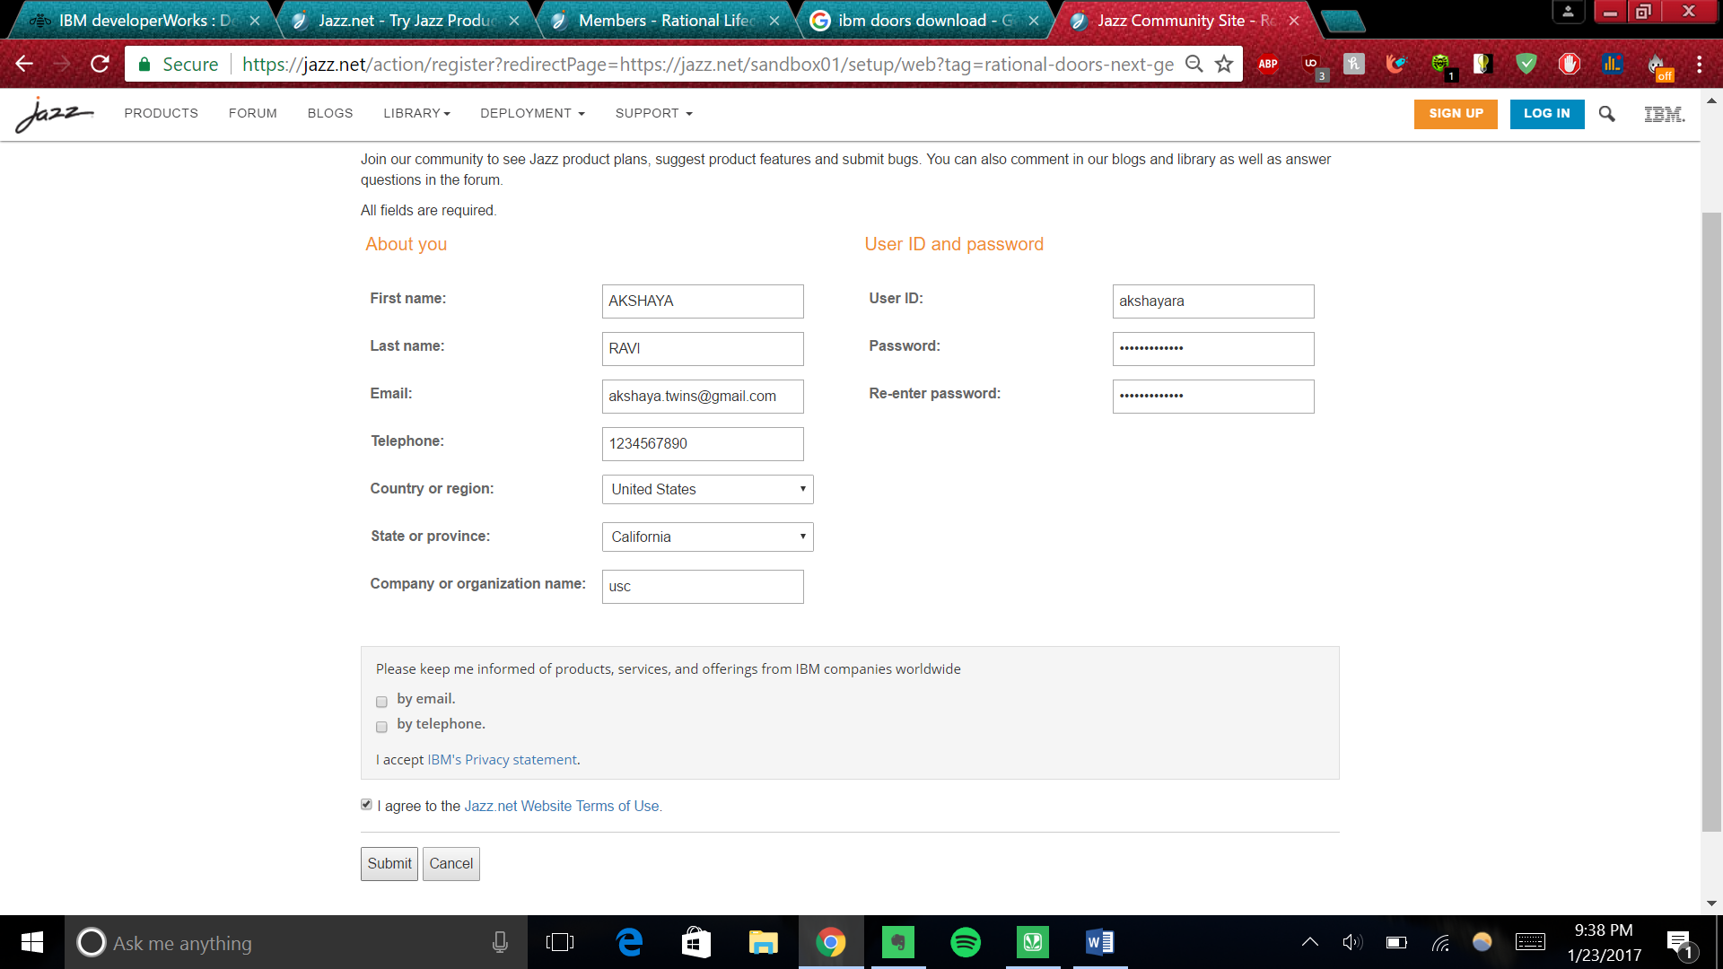

1. After registration, click on TRY.

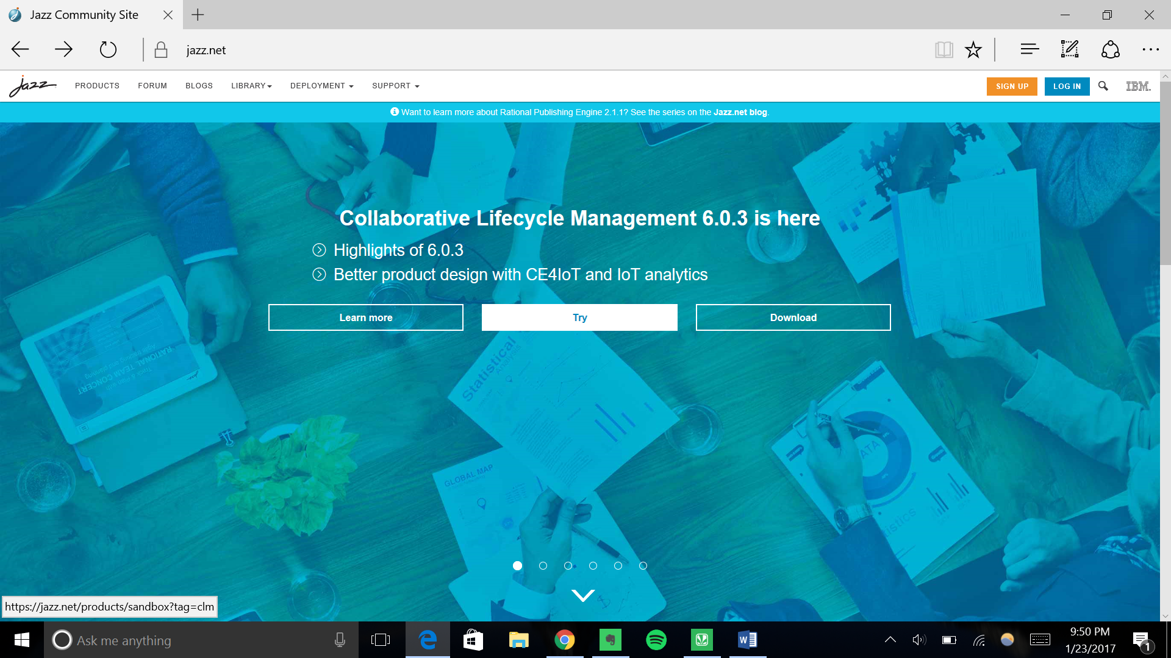

1. Ensure that you see 6.0.3 Latest Release before clicking on “let’s get started”.

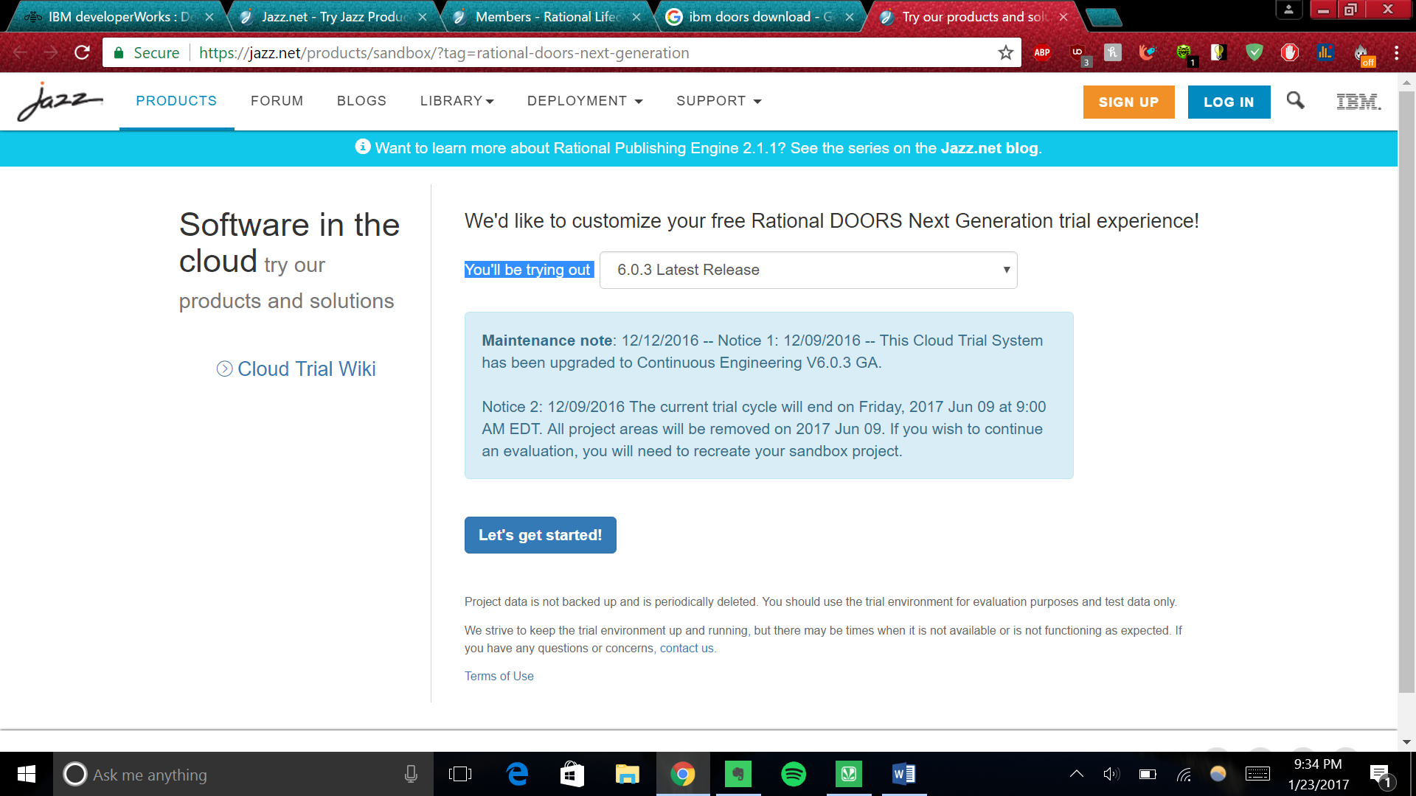

1. Enter your project name as **YourFullName(camel-cased LIKE AkshayaRavichandran)_CSCI568Project** and agree to terms. Click “create my project”.

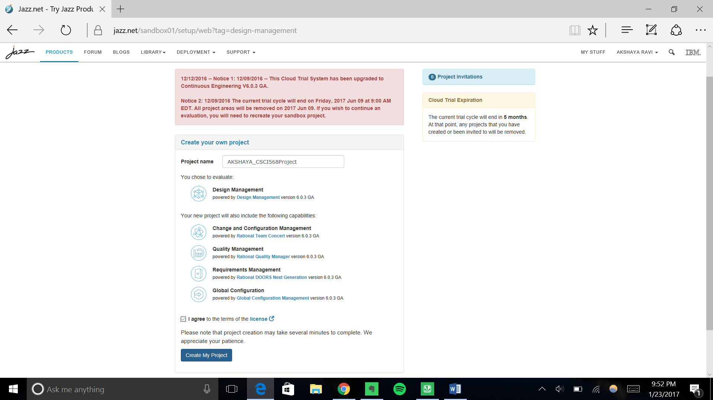

1. You should see the following- do not close window until project has been created. It might take some time.

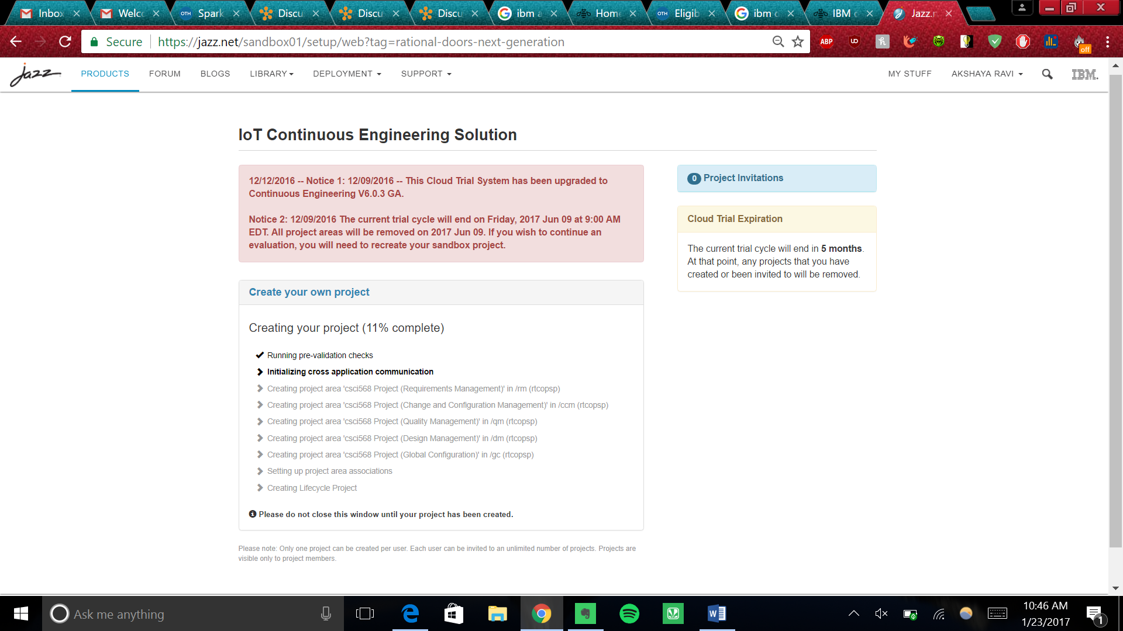

1. Click on the first link to land on your projects dashboard page.

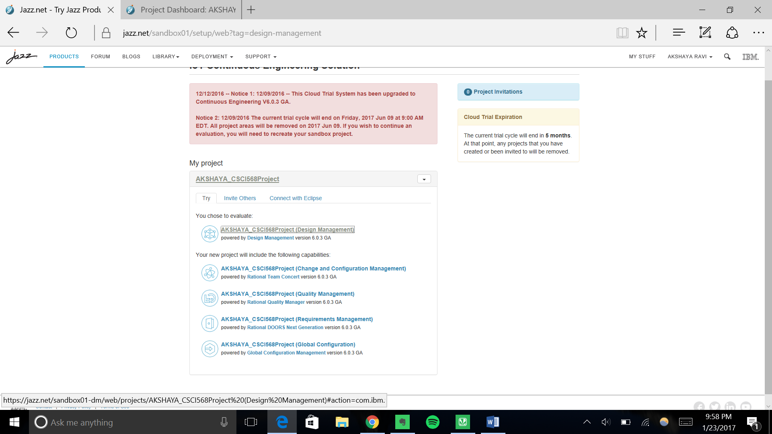

1. On top left corner you will see a **HOME icon**. Click on the drop down and **select All Projects from Requirements Management.**

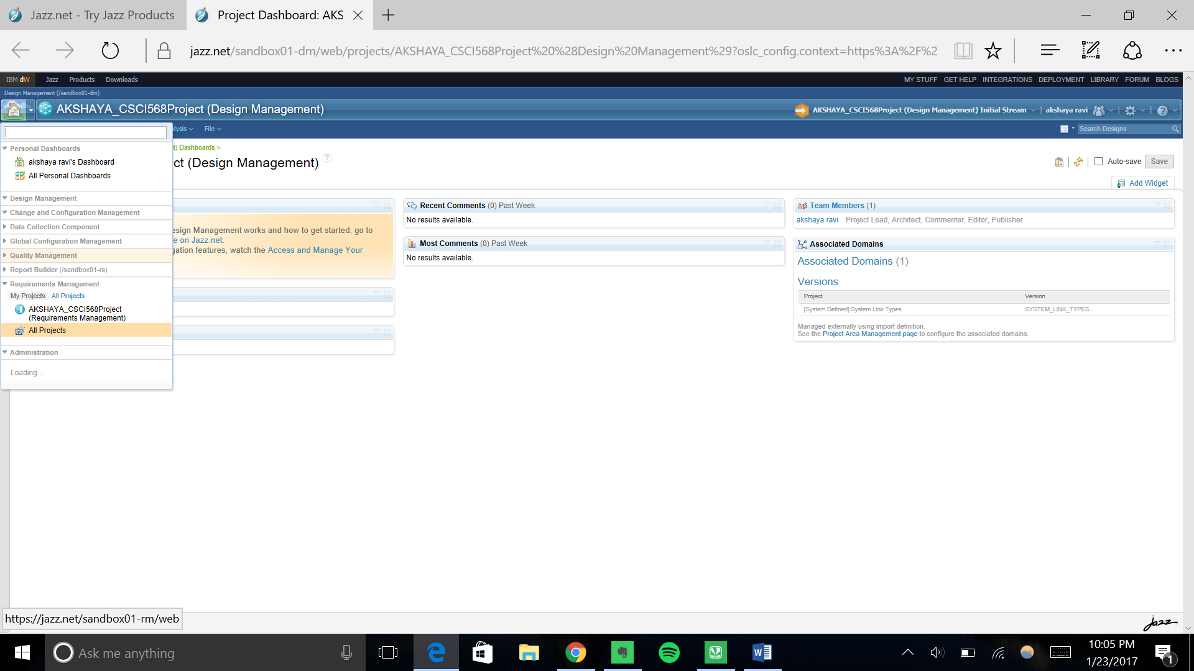

1. To add component to your project, click on “**Show Components**” and then “**New Component**”. Enter component name as the same name as your project name in this format- **YourFullName(camel-cased)_CSCI568PROJECT**. Also **add description** to include your **full name and usc email id**. Click on Next.

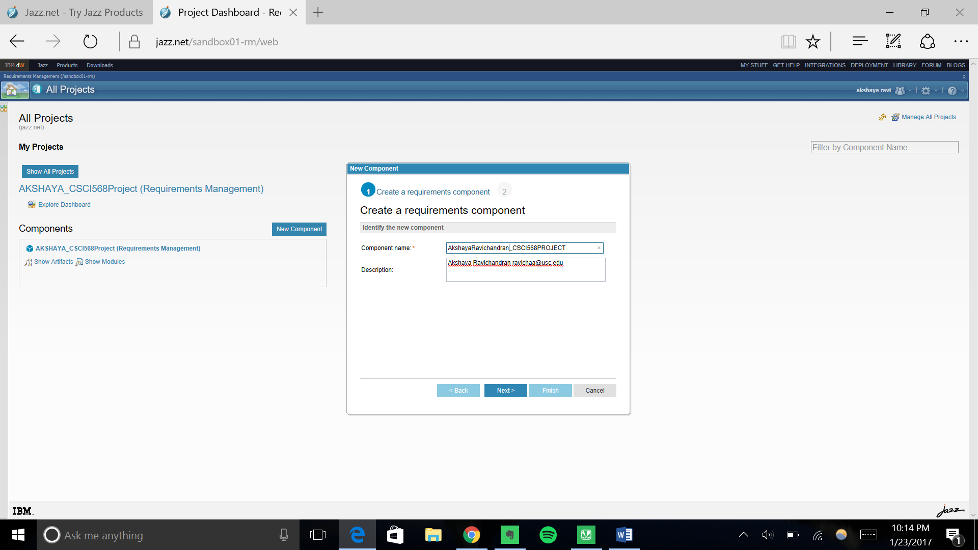

1. Check on the box “Use a template to initially populate the component” and from drop down choose “**Traditional Requirements Template”** (This template will help you get started with traditional requirements management) and then click on finish.

**CAREFUL: Do not choose “Traditional Requirements Sample”** 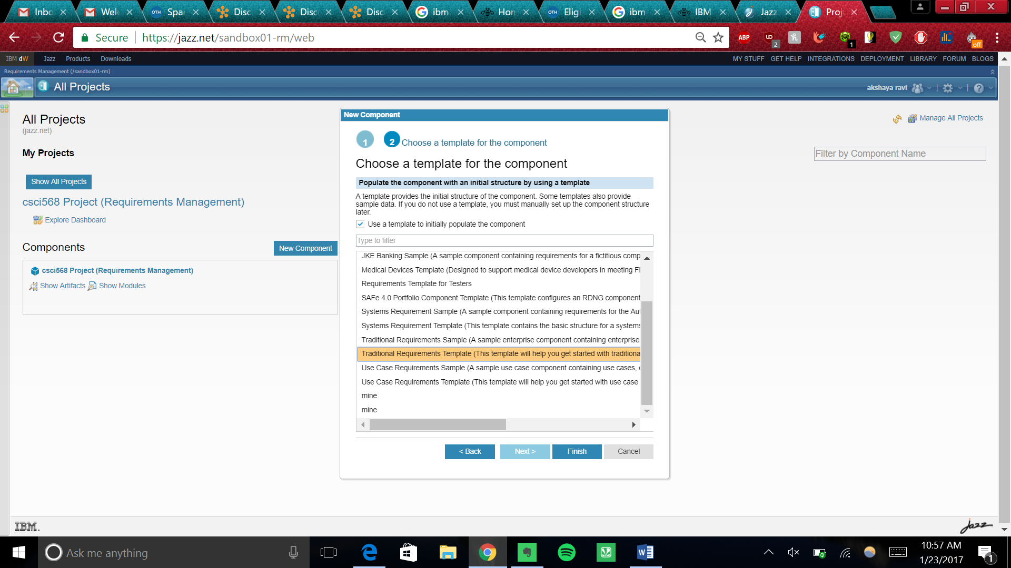

1. Last step is to invite members to your team to view and monitor your progress. To add team member, from the top left home icon button’s drop-down, click on life-cycle project administration.

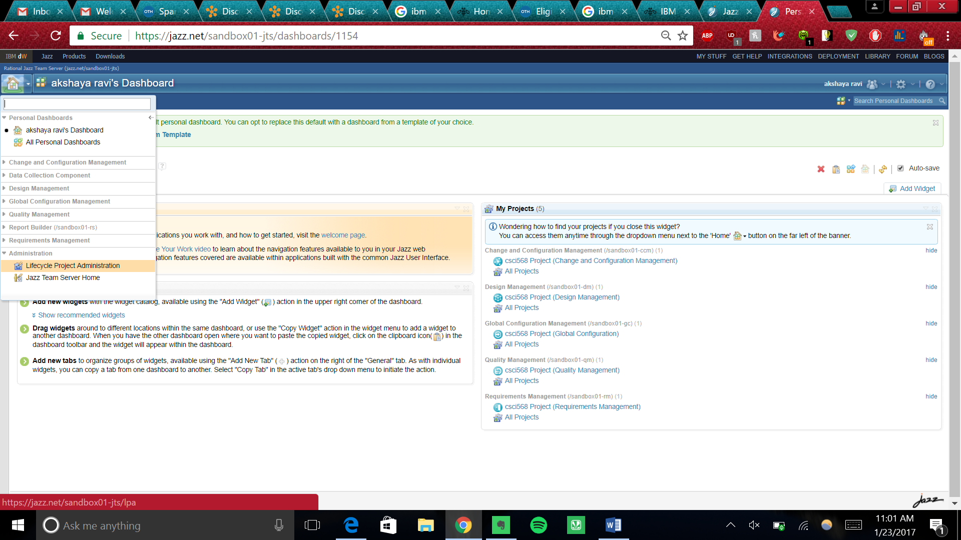

1. In the Life Cycle Project Administration page click on MEMBERS from header list bar (takes some time for all projects to load). Select “Add Members” from right top corner. **Search for Edwards** and choose “**drgedwards**”. **Click on add and don’t forget to click on “save” on top right corner after adding the member.**

